Name: Karanam Meghana
Reg no:192321126
QUESTION 1
1. Feature Descriptor Comparison — Harris vs SIFT
AIM
To design and perform an experiment to compare Harris Corner Detection and SIFT (Scale-Invariant Feature Transform) feature extraction on the same image, and analyze their performance in terms of feature quality, robustness, repeatability, and suitability for image matching.
TOOLS / SOFTWARE REQUIRED
- Python 3.x
- Jupyter Notebook / Google Colab / VS Code
- OpenCV (cv2)
- NumPy
- Matplotlib
- Input image
Install required libraries
pip install opencv-python numpy matplotlib
THEORY
Harris Corner Detection
Harris Corner Detection identifies points where the intensity changes significantly in both horizontal and vertical directions.
It calculates the Harris response:
where:
- M = structure tensor
- k = Harris constant, usually around 0.04–0.06
- Large positive R → corner
- Small/negative R → edge or flat region
Harris mainly detects corners/keypoints. It does not itself generate a scale- and rotation-invariant descriptor like SIFT.
SIFT
SIFT detects distinctive keypoints and generates a descriptor for each keypoint.
Main stages:
- Scale-space construction
- Difference-of-Gaussian calculation
- Keypoint localization
- Orientation assignment
- Descriptor generation
SIFT is designed to be robust to changes in:
- Scale
- Rotation
- Illumination to a useful degree
- Moderate viewpoint changes
PROCEDURE
Step 1: Read the input image
Load the same image using OpenCV and convert it into grayscale.
Step 2: Apply Harris Corner Detection
- Convert the image to grayscale.
- Convert the image to floating-point format.
- Apply cv2.cornerHarris().
- Dilate the result for better visualization.
- Mark pixels whose Harris response exceeds a threshold.
- Count the detected corners.
Step 3: Apply SIFT
- Create a SIFT detector using cv2.SIFT_create().
- Detect keypoints.
- Calculate SIFT descriptors.
- Draw the detected keypoints on the original image.
- Count the detected SIFT keypoints.
Step 4: Compare the results
Compare:
- Number of detected features
- Feature distribution
- Localization quality
- Robustness
- Repeatability
- Suitability for image matching
Step 5: Display the outputs
Display:
- Original image
- Harris corner detection result
- SIFT keypoint detection result

PYTHON CODE
import cv2
import numpy as np
import matplotlib.pyplot as plt
# -----------------------------------
# 1. Read Input Image
# -----------------------------------
image = cv2.imread("input.jpg")
if image is None:
print("Error: Image not found!")
exit()
gray = cv2.cvtColor(image, cv2.COLOR_BGR2GRAY)
# -----------------------------------
# 2. Harris Corner Detection
# -----------------------------------
gray_float = np.float32(gray)

harris = cv2.cornerHarris(
gray_float,
blockSize=2,
ksize=3,
k=0.04
)

# Dilate for visualization
harris_dilated = cv2.dilate(harris, None)

# Copy image for displaying Harris corners
harris_result = image.copy()

# Threshold Harris response
threshold = 0.01 * harris_dilated.max()

harris_result[harris_dilated > threshold] = [0, 0, 255]

# Count Harris corners
harris_count = np.sum(harris_dilated > threshold)

# -----------------------------------
# 3. SIFT Feature Extraction
# -----------------------------------

sift = cv2.SIFT_create()

keypoints, descriptors = sift.detectAndCompute(gray, None)

# Draw SIFT keypoints
sift_result = cv2.drawKeypoints(
image,
keypoints,
None,
flags=cv2.DRAW_MATCHES_FLAGS_DRAW_RICH_KEYPOINTS
)

# Number of SIFT keypoints
sift_count = len(keypoints)

# -----------------------------------
# 4. Display Results
# -----------------------------------

plt.figure(figsize=(15, 5))

plt.subplot(1, 3, 1)
plt.imshow(cv2.cvtColor(image, cv2.COLOR_BGR2RGB))
plt.title("Original Image")
plt.axis("off")

plt.subplot(1, 3, 2)
plt.imshow(cv2.cvtColor(harris_result, cv2.COLOR_BGR2RGB))
plt.title("Harris Corners")
plt.axis("off")

plt.subplot(1, 3, 3)
plt.imshow(cv2.cvtColor(sift_result, cv2.COLOR_BGR2RGB))
plt.title("SIFT Keypoints")
plt.axis("off")

plt.tight_layout()
plt.show()

# -----------------------------------
# 5. Display Feature Counts
# -----------------------------------

print("----- Feature Detection Results -----")
print("Number of Harris Corners:", harris_count)
print("Number of SIFT Keypoints:", sift_count)
if descriptors is not None:
print("SIFT Descriptor Shape:", descriptors.shape)
else:
print("No SIFT descriptors found.")

OUTPUT

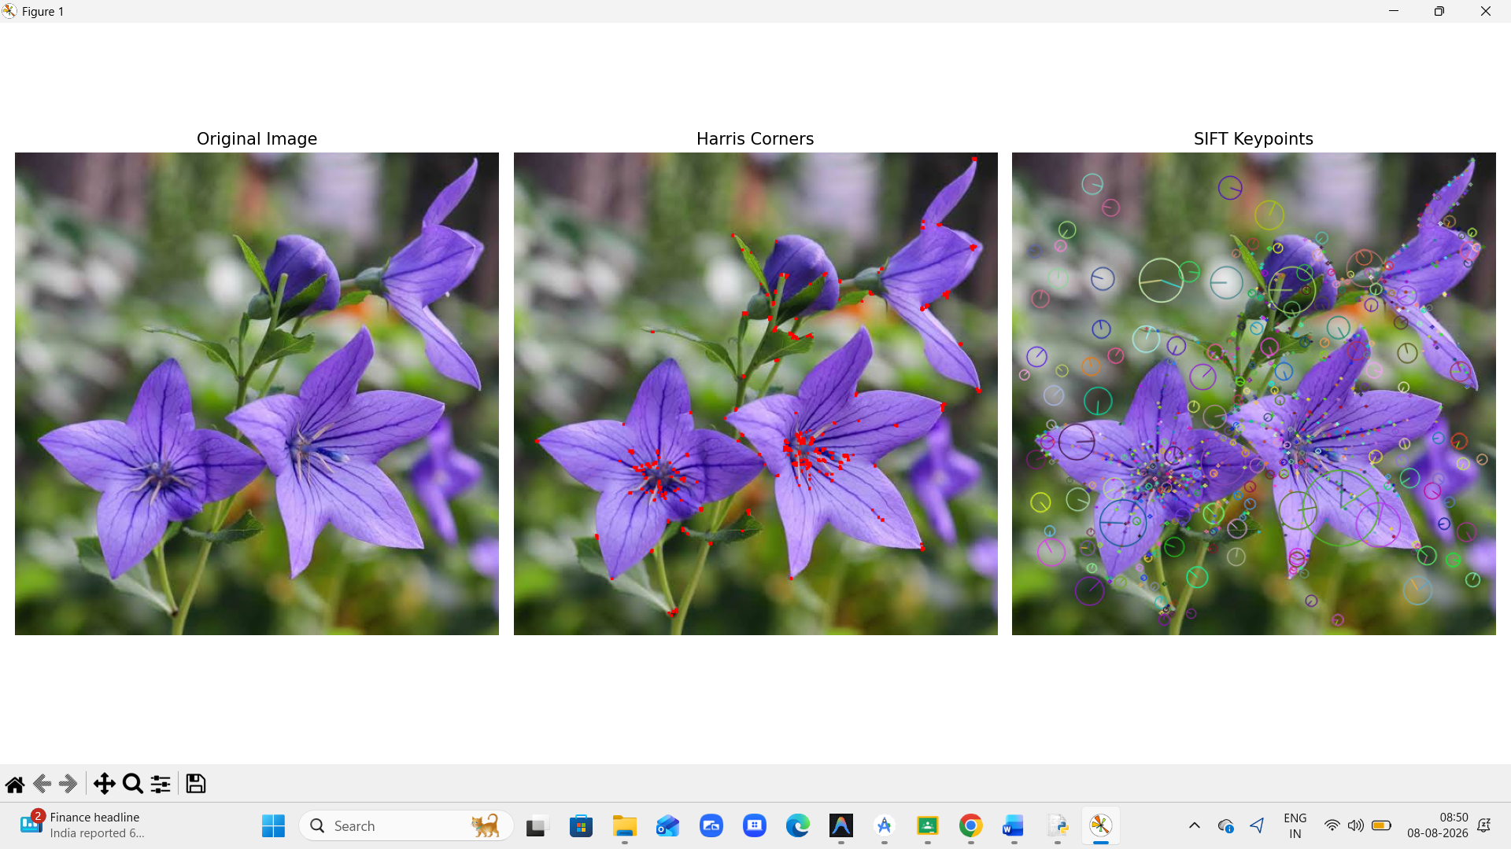

RESULT

The experiment successfully detects image features using Harris Corner Detection and SIFT. Harris effectively identifies corner points with relatively low computational cost, while SIFT detects distinctive keypoints and generates descriptors that are more suitable for matching the same objects across changes in scale and rotation.
QUESTION 2
2. Image Enhancement for Feature Detection
AIM
To evaluate the effect of image enhancement techniques such as Histogram Equalization and Contrast Adjustment on feature detection performance, and to analyze how enhancement influences feature visibility, detection accuracy, and reliability.
TOOLS / SOFTWARE REQUIRED
- Python 3.x
- OpenCV (cv2)
- NumPy
- Matplotlib
- Jupyter Notebook / Google Colab / VS Code
- Input image
THEORY
Image Enhancement
Image enhancement is the process of improving the visual quality of an image so that important features become easier to identify and process.
In computer vision, enhancement can improve:
- Contrast
- Feature visibility
- Edge information
- Object boundaries
- Keypoint detection
Two enhancement techniques used in this experiment are:
1. Histogram Equalization
Histogram equalization redistributes the intensity values of an image to improve its overall contrast.
It is particularly useful when an image has a narrow intensity range.
Original Image
↓
Calculate Histogram
↓
Redistribute Intensity Values
↓
Enhanced Image
2. Contrast Adjustment
Contrast adjustment expands or modifies the intensity range of an image.
A simple contrast transformation can be represented as:
where:
- f(x,y) = original pixel value
- α = contrast control
- β = brightness control
- g(x,y) = enhanced pixel value
A value of α > 1 increases contrast.
FEATURE DETECTION
In this experiment, SIFT feature detection is used after enhancement.
The same image is processed in three ways:
- Original image
- Histogram-equalized image
- Contrast-adjusted image
SIFT keypoints are detected in each version and the number of detected features is compared.
PROCEDURE
Step 1:Read the input image using OpenCV.
Step 2:Convert the image to grayscale.
Step 3:Apply Histogram Equalization using:
cv2.equalizeHist()
Step 4:Apply Contrast Adjustment using the transformation:
Step 5:Create a SIFT detector.
Step 6:Detect SIFT keypoints in:
- Original image
- Histogram-equalized image
- Contrast-adjusted image
Step 7:Draw the detected keypoints on each image.
Step 8:Count the number of detected keypoints.
Step 9:Display the original, enhanced images, and their detected features.
Step 10:Compare the results and analyze the effect of enhancement.
PYTHON CODE
import cv2
import numpy as np
import matplotlib.pyplot as plt
# ----------------------------------------
# 1. Read Input Image
# ----------------------------------------
image = cv2.imread("input.jpg")
if image is None:
print("Error: Image not found!")
exit()
# Convert to grayscale
gray = cv2.cvtColor(image, cv2.COLOR_BGR2GRAY
# ----------------------------------------
# 2. Histogram Equalization
# ----------------------------------------
equalized = cv2.equalizeHist(gray)
# ----------------------------------------
# 3. Contrast Adjustment
# ----------------------------------------
alpha = 1.5 # Contrast factor
beta = 0 # Brightness factor
contrast = cv2.convertScaleAbs(
gray,
alpha=alpha,
beta=beta
)
# ----------------------------------------
# 4. Create SIFT Detector
# ----------------------------------------
sift = cv2.SIFT_create()
# ----------------------------------------
# 5. Detect Features in Original Image
# ----------------------------------------
kp_original, des_original = sift.detectAndCompute(
gray,
None
)
original_features = cv2.drawKeypoints(
gray,
kp_original,
None,
flags=cv2.DRAW_MATCHES_FLAGS_DRAW_RICH_KEYPOINTS
)
# ----------------------------------------
# 6. Detect Features in Equalized Image
# ----------------------------------------
kp_equalized, des_equalized = sift.detectAndCompute(
equalized,
None
)
equalized_features = cv2.drawKeypoints(
equalized,
kp_equalized,
None,
flags=cv2.DRAW_MATCHES_FLAGS_DRAW_RICH_KEYPOINTS
)
# ----------------------------------------
# 7. Detect Features in Contrast Image
# ---------------------------------------
kp_contrast, des_contrast = sift.detectAndCompute(
contrast,
None
)
contrast_features = cv2.drawKeypoints(
contrast,
kp_contrast,
None,
flags=cv2.DRAW_MATCHES_FLAGS_DRAW_RICH_KEYPOINTS
)
# ----------------------------------------
# 8. Display Results
# ----------------------------------------
plt.figure(figsize=(15, 10))
plt.subplot(2, 3, 1)
plt.imshow(gray, cmap="gray")
plt.title("Original Grayscale")
plt.axis("off")
plt.subplot(2, 3, 2)
plt.imshow(equalized, cmap="gray")
plt.title("Histogram Equalized")
plt.axis("off")
plt.subplot(2, 3, 3)
plt.imshow(contrast, cmap="gray")
plt.title("Contrast Adjusted")
plt.axis("off")
plt.subplot(2, 3, 4)
plt.imshow(original_features, cmap="gray")
plt.title("Features - Original")
plt.axis("off")
plt.subplot(2, 3, 5)
plt.imshow(equalized_features, cmap="gray")
plt.title("Features - Equalized")
plt.axis("off")
plt.subplot(2, 3, 6)
plt.imshow(contrast_features, cmap="gray")
plt.title("Features - Contrast")
plt.axis("off")
plt.tight_layout()
plt.show()
# ----------------------------------------
# 9. Display Feature Counts
# --------------------------------------
print("-----------------------------------")
print("FEATURE DETECTION RESULTS")
print("-----------------------------------")
print("Original Image Features:",
len(kp_original))
print("Histogram Equalized Features:",
len(kp_equalized)
print("Contrast Adjusted Features:",
len(kp_contrast))
OUTPUT
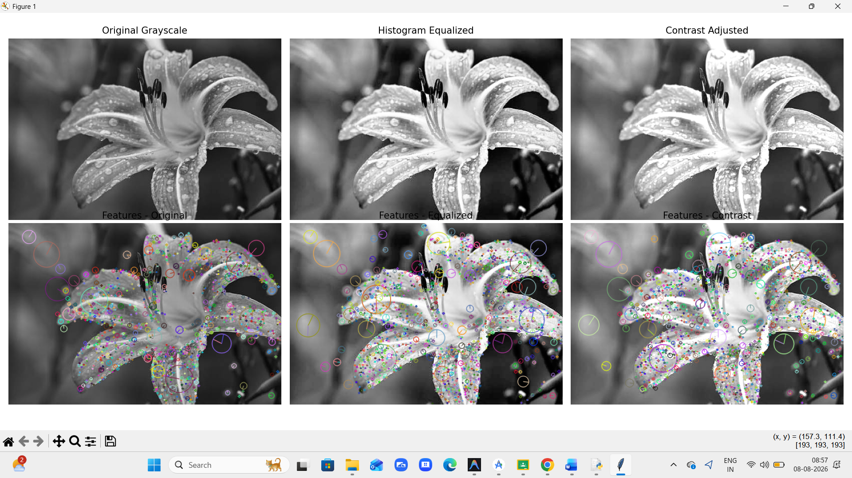
RESULT
The experiment demonstrates that image enhancement can influence feature detection performance. Histogram equalization and contrast adjustment improve the visibility of intensity variations and can change the number and distribution of detected SIFT features.
QUESTION 3
AIM
To study feature detection at different image scales and analyze the effect of scale on feature stability, accuracy, and processing time.
TOOLS
- Python
- OpenCV
- NumPy
- Matplotlib
- Jupyter Notebook / VS Code
PROCEDURE
- Read the input image.
- Convert it to grayscale.
- Resize the image to 100%, 75%, 50%, and 25%.
- Apply SIFT feature detection to each scale.
- Count the detected keypoints.
- Record the processing time.
- Compare the results.
CODE
import cv2
import matplotlib.pyplot as plt
img = cv2.imread("input3.jpeg")
gray = cv2.cvtColor(img, cv2.COLOR_BGR2GRAY)
sift = cv2.SIFT_create()
scales = [1.0, 0.75, 0.5, 0.25]
plt.figure(figsize=(12, 8))
for i, scale in enumerate(scales):
resized = cv2.resize(gray, None, fx=scale, fy=scale)
keypoints, descriptors = sift.detectAndCompute(resized, None)
output = cv2.drawKeypoints(
resized,
keypoints,
None,
flags=cv2.DRAW_MATCHES_FLAGS_DRAW_RICH_KEYPOINTS
)
plt.subplot(2, 2, i + 1)
plt.imshow(output, cmap="gray")
plt.title(f"Scale {scale*100:.0f}% - {len(keypoints)} Features")
plt.axis("off")
plt.tight_layout()
plt.show()
OUTPUT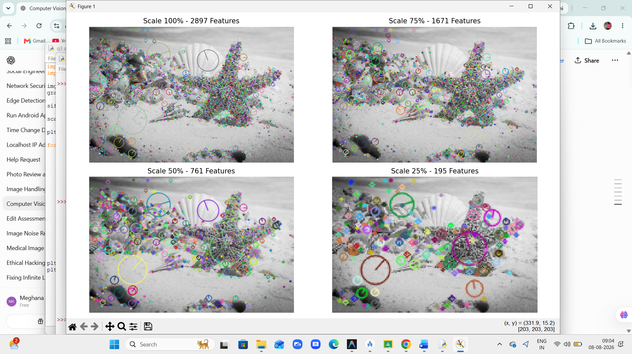
RESULT
SIFT features were successfully detected at different image scales. As image size decreases, processing time generally decreases, but some fine features may be lost.

QUESTION 4
AIM
To compare Mean, Gaussian, and Median filtering for image preprocessing and analyze their effectiveness in noise reduction while preserving important image features.
TOOLS
- Python
- OpenCV
- NumPy
- Matplotlib
- Jupyter Notebook / VS Code
PROCEDURE
- Read the input image.
- Convert it to grayscale.
- Add noise to the image.
- Apply Mean, Gaussian, and Median filters.
- Display the original, noisy, and filtered images.
- Compare noise reduction and feature preservation.
THEORY
- Mean Filter: Replaces each pixel with the average of neighboring pixels. It reduces noise but may blur edges.
- Gaussian Filter: Uses a Gaussian-weighted average. It provides smoother results with better edge preservation than a simple mean filter.
- Median Filter: Replaces a pixel with the median of its neighborhood. It is particularly effective for salt-and-pepper noise while preserving edges.
CODE
import cv2
import numpy as np
import matplotlib.pyplot as plt
# Read image
img = cv2.imread("input4.jpeg")
gray = cv2.cvtColor(img, cv2.COLOR_BGR2GRAY)
# Add salt and pepper noise
noise = gray.copy()
prob = 0.05
random = np.random.rand(*gray.shape)
noise[random < prob/2] = 0
noise[random > 1 - prob/2] = 255
# Apply filters
mean = cv2.blur(noise, (5, 5))
gaussian = cv2.GaussianBlur(noise, (5, 5), 0)
median = cv2.medianBlur(noise, 5)
# Display results
plt.figure(figsize=(12, 8))
plt.subplot(2, 3, 1)
plt.imshow(gray, cmap="gray")
plt.title("Original")
plt.axis("off")
plt.subplot(2, 3, 2)
plt.imshow(noise, cmap="gray")
plt.title("Noisy Image")
plt.axis("off")
plt.subplot(2, 3, 3)
plt.imshow(mean, cmap="gray")
plt.title("Mean Filter")
plt.axis("off")
plt.subplot(2, 3, 4)
plt.imshow(gaussian, cmap="gray")
plt.title("Gaussian Filter")
plt.axis("off")
plt.subplot(2, 3, 5)
plt.imshow(median, cmap="gray")
plt.title("Median Filter")
plt.axis("off")
plt.tight_layout()
plt.show()
OUTPUT
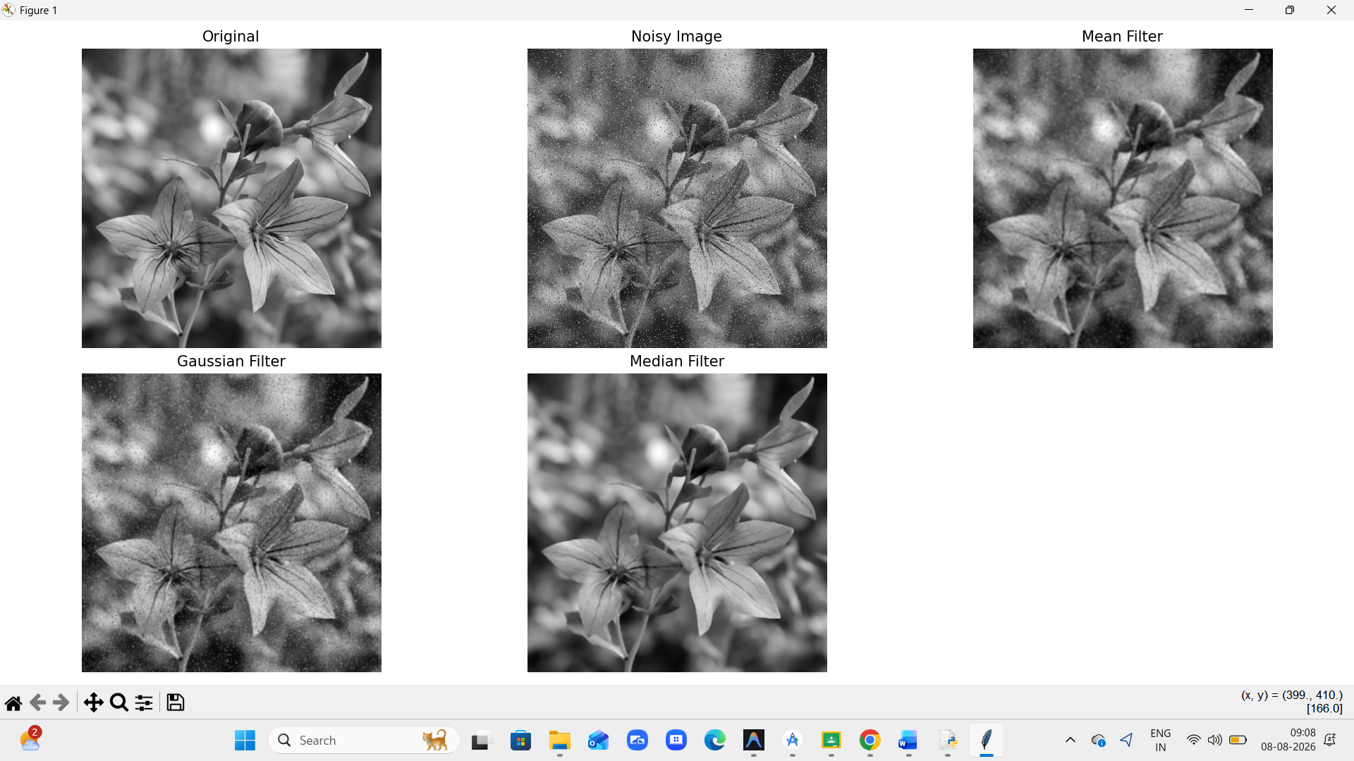
RESULT
The Mean, Gaussian, and Median filters were successfully implemented. The Median filter provides better removal of salt-and-pepper noise while preserving important edges, whereas the Mean filter may cause more blurring. The Gaussian filter provides smooth noise reduction with relatively good feature preservation.

QUESTION 5
5. Complete Object Detection Workflow
AIM
To develop a complete object detection workflow using image preprocessing, edge detection, feature extraction, and shape detection, and analyze its effectiveness under different image conditions.
TOOLS
- Python
- OpenCV
- NumPy
- Matplotlib
- Jupyter Notebook / VS Code
PROCEDURE
- Read the input image.
- Convert it to grayscale.
- Apply Gaussian filtering for noise reduction.
- Perform Canny edge detection.
- Extract important features from the edges.
- Detect object shapes using Hough Circle Transform.
- Display the output at every stage.
- Analyze the final detected objects.
WORKFLOW

Input Image
↓
Grayscale Conversion
↓
Gaussian Filtering
↓
Canny Edge Detection
↓
Feature Extraction
↓
Shape Detection
↓
Detected Object

CODE
import cv2
import matplotlib.pyplot as plt
# Read image
img = cv2.imread("input.jpg")
# 1. Grayscale
gray = cv2.cvtColor(img, cv2.COLOR_BGR2GRAY)
# 2. Preprocessing
blur = cv2.GaussianBlur(gray, (5, 5), 0)
# 3. Edge Detection
edges = cv2.Canny(blur, 50, 150)
# 4. Feature Extraction
contours, _ = cv2.findContours(
edges,
cv2.RETR_EXTERNAL,
cv2.CHAIN_APPROX_SIMPLE
)
feature_img = img.copy()
cv2.drawContours(feature_img, contours, -1, (0, 255, 0), 2)
# 5. Shape Detection - Circles
circles = cv2.HoughCircles(
blur,
cv2.HOUGH_GRADIENT,
dp=1,
minDist=30,
param1=50,
param2=30,
minRadius=10,
maxRadius=100
)
shape_img = img.copy()
if circles is not None:
circles = circles.astype(int)
for x, y, r in circles[0]:
cv2.circle(shape_img, (x, y), r, (0, 0, 255), 2)
cv2.circle(shape_img, (x, y), 2, (0, 255, 0), 3)
# Display outputs
plt.figure(figsize=(12, 8))
plt.subplot(2, 3, 1)
plt.imshow(cv2.cvtColor(img, cv2.COLOR_BGR2RGB))
plt.title("Original Image")
plt.axis("off")
plt.subplot(2, 3, 2)
plt.imshow(gray, cmap="gray")
plt.title("Grayscale")
plt.axis("off")
plt.subplot(2, 3, 3)
plt.imshow(blur, cmap="gray")
plt.title("Preprocessed")
plt.axis("off")
plt.subplot(2, 3, 4)
plt.imshow(edges, cmap="gray")
plt.title("Canny Edges")
plt.axis("off")
plt.subplot(2, 3, 5)
plt.imshow(cv2.cvtColor(feature_img, cv2.COLOR_BGR2RGB))
plt.title("Features / Contours")
plt.axis("off")

plt.subplot(2, 3, 6)
plt.imshow(cv2.cvtColor(shape_img, cv2.COLOR_BGR2RGB))
plt.title("Shape Detection")
plt.axis("off")
plt.tight_layout()
plt.show()
OUTPUT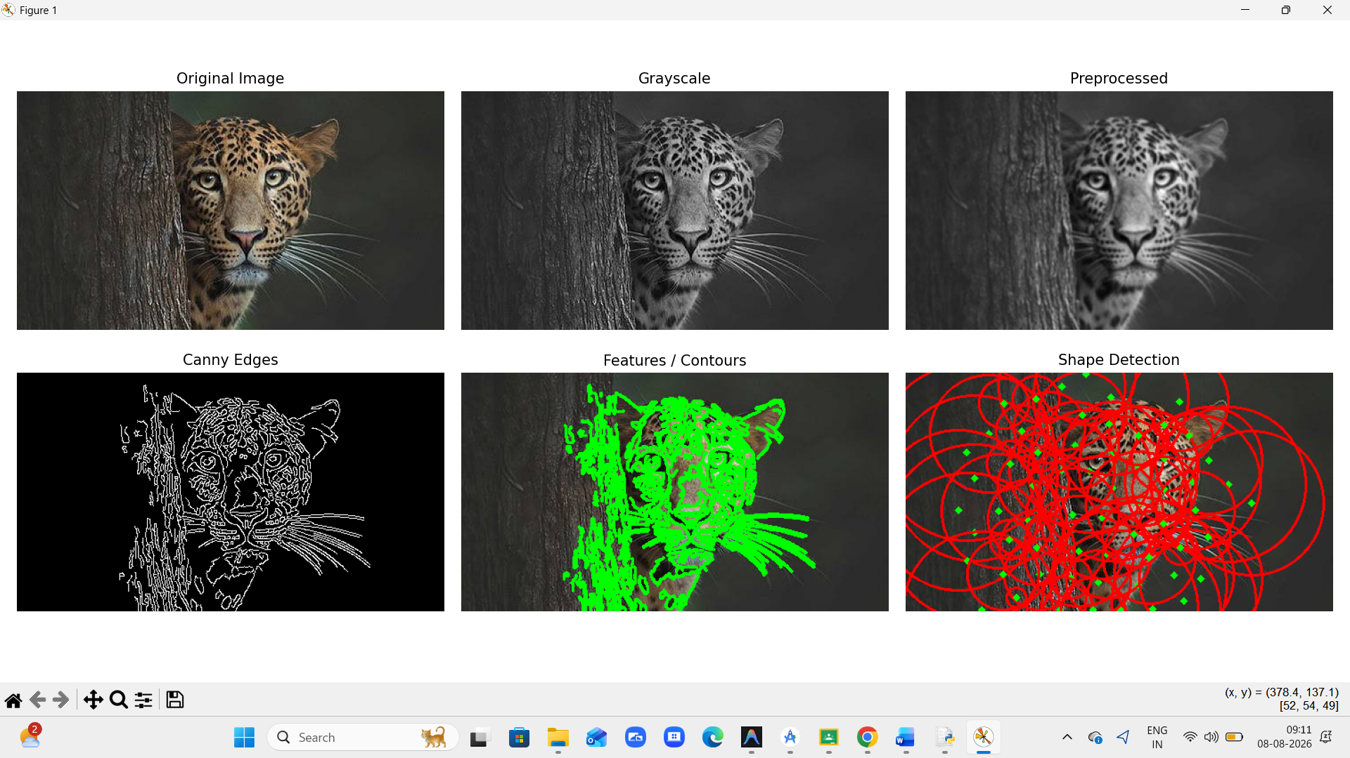
RESULT
The complete object detection pipeline was successfully implemented. Preprocessing reduces noise, edge detection identifies boundaries, feature extraction identifies object regions, and shape detection recognizes the required shapes. The integrated workflow provides more reliable detection when the image has clear edges and limited noise.

